Vogel Vogel
Registration Number 100431880
2026

Investigation and simulation of card counting methods for blackjack

Supervised by: Mohsin Raza


University of East Anglia
Faculty of Science
School of Computing Science

  - Formatted using appropriate MS Word or Latex Template.
  - Have no more than 40 single sided pages for the body text (including bibliography but excluding title and TOC page) and 20 pages for the appendices.

Introduction
This aim of this paper is to investigate different methods of card counting in the game of Blackjack (BJ) and their comparative success over a period of time.

Background
Game theory finds its foundational origins in a 1928 paper entitled ‘On the theory of games of strategy’ written by man of many fields, John Von Neumann.

Methodology
My initial plans were for a html and javascript structured web-based solution, however I quickly deemed this overly complex for a system where the visual aspects were the least important of all areas of the problem.

I moved to a class based structure utilising Java’s Object-Oriented Approach.

Experimental Plan
My designs for measuring and comparing the effectiveness of the different methods was to record the player chip count over a period of time and create a normalised histogram over a set period of 10,000 hands.

Development of Programming Code
Architecture of basic strategy
Architecture of gameplay loop

Software Testing Results
Results of what testing I was able to do

Strategy

Counting

Analysis Results
A

Conclusion and Future Work
What I would have done had I had more time.

Headings and Sub-headings
This is section heading

Sub-section headings
Sub-section headings

Sub-sub-section headings
Sub-sub-section headings

Sub-sub-section headings
Another sub-sub-section headings

Figure Example (with caption)
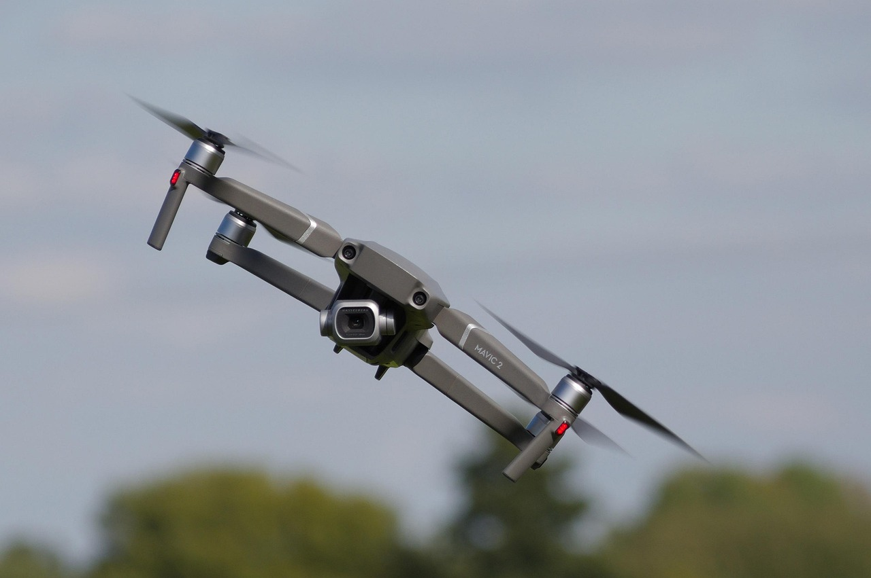
Figure 1: Example figure caption { License summary: https://pixabay.com/service/license-summary/} {Source: https://pixabay.com/photos/mavic-2-drone-dynamic-action-bokeh-7870679/ , last viewed 17 Nov 2025}

Equation Example
An example equation:
E = mc² (1)
${\left(x+a\right)}^{n}=\sum_{k=0}^{n}{\left({n \atop k}\right)x^{k}a^{n-k}}$ (2)

Table Example
Table 1 Random Values
R1C1 | R1C2 | R1C3
R2C1 | R2C2 | R2C3
R3C1 | R3C2 | R3C3

References and citations
In all your work it is essential to show the sources of information on which it is based. This:
- Provides support and justification for the points you’re making,
- Allows a reader or reviewer to appreciate your knowledge of the topic,
- Lets a reader follow up a point they’re interested in,
- Acknowledges the work of others,
- Shows how your work is related to previous work in the same area (in project reports, dissertations and theses).
The information about each publication should be sufficient to allow a reader to easily find the publication and to make an initial assessment of the publication's quality.
The publication details are essential because academic papers are reviewed by suitably qualified experts before being accepted for publication. The number and quality of reviews, and the acceptance criteria vary, but well-respected international journals and conferences generally have more rigorous acceptance criteria, more and better quality reviews of papers. Reputable publishers of academic books, government agencies and major commercial research labs (e.g. Google, IBM, Nielsen-Norman Group) have similar review processes which provide a quality assurance mechanism for academic and technical publications; this is generally lacking for other forms of publication.

Citations and References
The notes in this section describe the standards and conventions for citations and references . They are applicable to all written work in the School. There are two parts:
Citation. This is the reference in the text to the work you are referring to
"... the remainder of this section is based on the work reported in (Farmer and Watro 1989a)."
"Some writers (e.g. (Vonk 1990)) see this as one of the principal classes of prototype..."
"Gray's (1978) pioneering work in this area ..."
" The first linear hashing algorithm (Litwin 1980) ..."
References (or Bibliography). This is the section at the end of the report which lists the works cited, in alphabetical order.
Text citations
- All citations must be given using the author-date ("Harvard") system, which corresponds to the "APAlike" LaTeX bibliography style.
- Citations should give the author's surname, the date of publication and, if required, a page number, e.g. (Knuth, 1998: 20).
- For sources of figures and tables, give the author name and date in the caption; give the full details in the reference list.
- Several citations together should be listed in either date order (Harvey 2021; Jones 2022; Williams in press).
- Personal communications and unpublished data should be cited in full in the text, and should not be included in the reference list (e.g. R. A. Smith, personal communication 2019).
- Citations to works with two authors should give both names, e.g. (Smith and Jones 2020).
- Citations to works with three or more authors should use et al., the abbreviation of the Latin 'and others' (e.g. Garcia-Molina et al. 2008).
“The main advantage of the author–date system is that it is concise and easy for the reader to follow” (CUP Style Guide). There are two other reasons for preferring the author-year
citation format: first, it means that you become more familiar with the key works and names of researchers in the subject, second, it makes it easier for faculty to mark your work.

References section
- The References section must contain only works that are cited in the text. There are never separate References and Bibliography sections. The references section is never subdivided.
- All works cited in the text (including sources for figures and tables) must be included in the list of references at the end of the essay, report or dissertation. The references are sorted by author and then by year.
- All references listed must be cited in the text.
- The reference list should be headed with an unnumbered section heading 'References'.
- Ensure that every reference is complete, giving the following minimal information:
Type of work | Details required
book | author(s)/editor(s), year, title, publisher (place of publication)
part of a book | author(s), year, title, chapter/pages, book editor(s), book title, publisher (place of publication)
conference paper | author(s), year, title, conference title, pages (URL/DOI)
journal paper | author(s), year, title, journal, volume (issue), pages (URL/DOI)
manual | organization, year, title
technical report | author(s)/editor(s), year, title, institution
thesis | author, year, title, institution
Web site | author(s), year, site name/subject, URL
Items in parentheses are not always available, but should be included if possible.
Author names are in the form: surname initial(s), e.g. Milner B.P.
Many papers are available online – for these you should give the full publication details followed by the DOI. A URL alone is not adequate.
Any URL you give should be a direct reference, not a query specification (i.e. a GET method). If a URL contains ampersands (&) it is a query specification.

Presentation of references
Some details are provided here. Refer to https://uea-uk.libguides.com/referencing for further guidance.
If you are using LaTeX and BibTeX the software will take care of the presentation of references – provided that you have supplied the BibTeX data correctly. For Word, if the authors and years of publication are correctly presented, using the guidance in this and the following section, a sort by paragraph of the references list will give the correct ordering.
- Works by the same first author must be in alphabetical order by first author surname then year, irrespective of the number of authors, e.g.:
Parr (2015)
Parr, Wang and Ren (2021)
Parr and Asif (2023)
- Works by the same author(s) in the same year should be distinguished by using lowercase a, b etc., e.g.:
(Cawley 2018a)
(Cawley 2018b)
- Works that have been accepted for publication or are in press should be listed as 'forthcoming' in the references list
- Journal and conference titles may be either in full, or abbreviated, but they should all be treated the same way and must be italicised.
- Book and journal titles normally have maximum capitalisation (all significant words start with an upper-case letter) and should be italicised.
- Article and chapter titles normally have minimum capitalisation (first letter only upper case) and are not iticalicised.
- Author names should be separated by 'and'
- Volume and pages numbers should be given as numbers (e.g. 5, 93-122) and are not prefixed with 'Vol', 'p.' etc. Issues of a volume should be given in parentheses immediately after the volume number (e.g. 16(4), 23-29).
Web page references
Software and other resources
Where you need to refer to a website for material such as the source of a program you have used, you should include it as a footnote. For example:
"For these experiments we used the Stanford POS tagger ..."
Papers
1. If you are referencing a page that is not published conventionally you should include the page's author(s) if they are named (this acknowledges their contribution) and the title of the page.
2. Provide the URL or DOI (see below) of a paper as well as the conventional publication details.
3. If the page has no authors or editors listed you should treat the organisation publishing the page as the author.
Examples:
These three examples (Caldwell et al. (2004); CUP n.d.; Whitenton (2015)) show various forms of reference for online publications:
Caldwell B., Chisholm W., Vanderheiden G., White J. (eds) (2004) Web Content Accessibility Guidelines 2.0, http://www.w3.org/TR/WCAG20/
CUP Style Guide
https://www.cambridge.org/authorhub/application/files/6015/5232/1970/40434_StyleGui de_web.pdf

Whitenton K. (2015), Change Blindness Causes People to Ignore What Designers Expect
Them to See https://www.nngroup.com/articles/change-blindness/
DOI
Most publishers have adopted the DOI (Digital Object Identifier) standard to provide unique references to their papers – if a DOI is available for a work you reference, you should include it as part of the reference, as it should remain valid even if the URL is changed.
Example references
The examples below are citations and references for a book (Anderson 2020), two journal papers - the second of which has its volumes divided into issues (Sieck et al. 2021; Samuelson 2023), a conference paper (Leist and Smith 2016), a technical report (Sawhney 1997), a part of a book (DeWitt 1991), a thesis (Couvreur 1997), and an online manual (Mozilla JavaScript 2023).
Examples:
Anderson R. (2020) Security Engineering: A Guide to Building Dependable Distributed Systems, Wiley (also at https://www.cl.cam.ac.uk/~rja14/book.html)
Couvreur C. (1997) Environmental Sound Recognition: A Statistical Approach, PhD thesis, Faculté Polytechnique de Mons, Belgium
DeWitt, D.J. (1991) The Wisconsin Benchmark: Past, Present and Future, in Gray, J. The Benchmark Handbook, Morgan Kaufmann, San Mateo
Leist E., Smith D.J (2016) Accessibility Issues in E-Government. EGOVIS 2014 LNCS 8650: 1525
Mozilla JavaScript, (2023) JavaScript https://developer.mozilla.org/enUS/docs/Web/JavaScript
Samuelson P. (2023) Legal Challenges to Generative AI, Part I, CACM 66(7):20-23, https://doi.org/10.1145/3597151
Sawhney N. (1997) Situational Awareness from Environmental Sounds, Technical Report for Modeling Adaptive Behavior (MAS 738), Pattie Maes, MIT Media Lab
Sieck C.J., Sheon A, Ancker J.S., Castek J., Callahan B. and Siefer A. (2021) Digital inclusion as a social determinant of health, npj Digital Medicine 4:52, https://doi.org/10.1038/s41746021-00413-8
Bibliography
Gowers E. (2014) Plain Words: A Guide to the Use of English, Penguin
Lamport L. (1999) LaTeX: A Document Preparation System, Addison Wesley, Reading, Mass.
Smith D (2018) Hints on Writing for Computing Assignments, Technical Report UEA School of Computing Sciences
Zobel J. (2015) Writing for Computer Science (3e), Springer, Berlin

